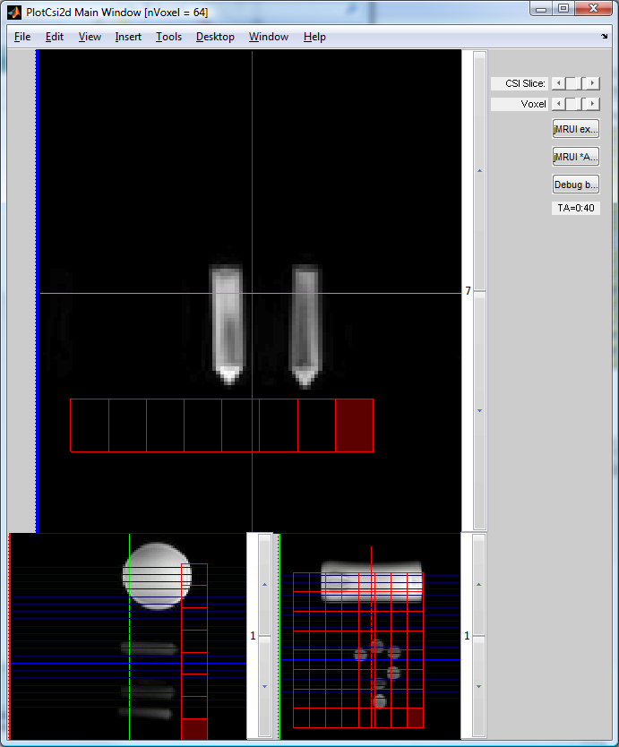
1 June 2010

PlotCsi2d voxel geometry is still not quite right.
MATLAB vs Syngo for C:\Users\crodgers\Documents\TrioData\
2010-05\20100524_CTR_test_CSI_8x8x8
Look at CSI slice 6 because it is most distinctive w.r.t. the phantom.
SVN revision 3340 shown here.
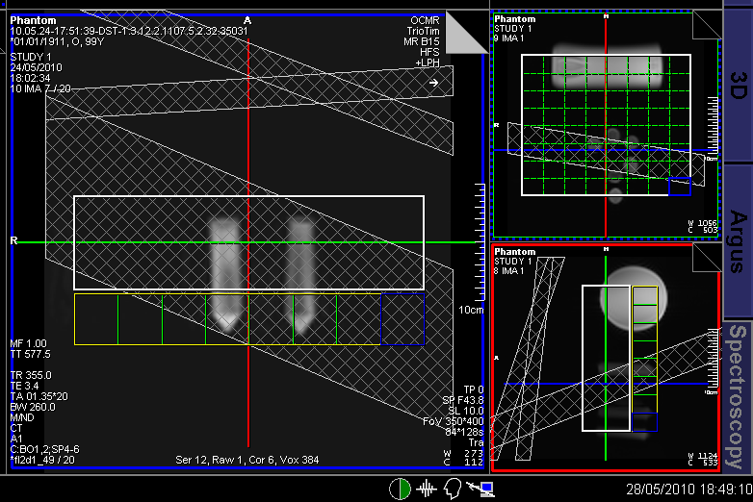

- Need to check that the images are exactly right. Best way might be to collect data with huge difference between resolution in PE direction and perp. That way if we’re flipped, the image will appear very distorted.
- Collect localizers with many slices to check registration
- Collect with x,y,z sizes unequal in localizers to check # rows and # cols correctly allocated.
- Collect with interpolated CSI to check that.
- Collect with x,y,z unequal in CSI to check # rows and # cols correctly allocated.

QUERY: Is the Siemens interpretation of the DICOM standard for geometry correct?
Q: Does it agree with the pulse sequence itself?

New version:
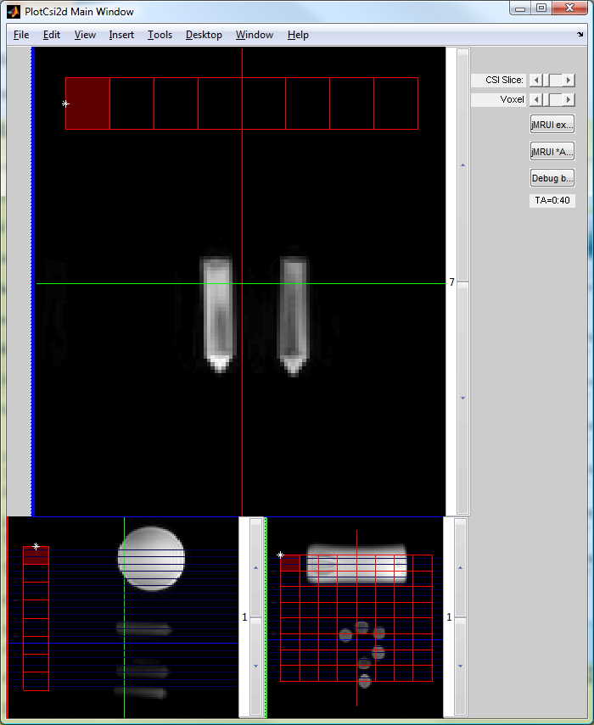
* marks “ImagePosition”

CSI slice 1 looks great

